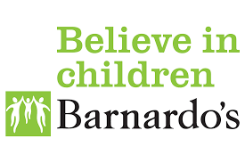
COST OF LIVING CRISIS HELPLINE
Call Barnados on 0808 500 0045
If you are struggling with the cost of managing your household, worried about how you are going to pay the bills, feeling the squeeze on your finances, Barnardos can help. This type of worry can not only impact financially but also emotionally. Don’t suffer in silence or think that you are alone. Call the Barnardos Cost-Of-Living Helpline to speak to one of their Advisors.
As a result of the ongoing Cost-Of-Living crisis, Barnardos has set up a dedicated Helpline to support parents and young people across the UK.
This is currently an additional resource for families being supported by Barnardo's. We hope to extend this offer outside of Barnardo's in the near future.
If you are struggling with the cost of managing your household, worried about how you are going to pay the bills, feeling the squeeze on your finances, we can help. This type of worry can not only impact financially but also emotionally. Don’t suffer in silence or think that you are alone. Call the Barnardos Cost-Of-Living Helpline to speak to one of our Advisors.
What can we support you with?
- We can apply for financial support for your family such as the Barnardos Cost-Of-Living emergency fund, Children In Need applications and provide Food Bank Vouchers.
- We can make referrals to Barnardos Link therapy service. This will include 7 sessions, 30 minutes per session over the phone with a trained therapist to discuss your emotions/feelings and strategies to help you cope with the difficulties you are experiencing. An interpreter can also join the sessions, if required.
- We can signpost to organisations that can support you further in this time of need.

Helpline details
Monday – Saturday (9.30am-5.30pm)
via phone 0808 500 0045
and by email COLHelpline@barnardos.org.uk

