Child Friendly Anti - Bullying Policy
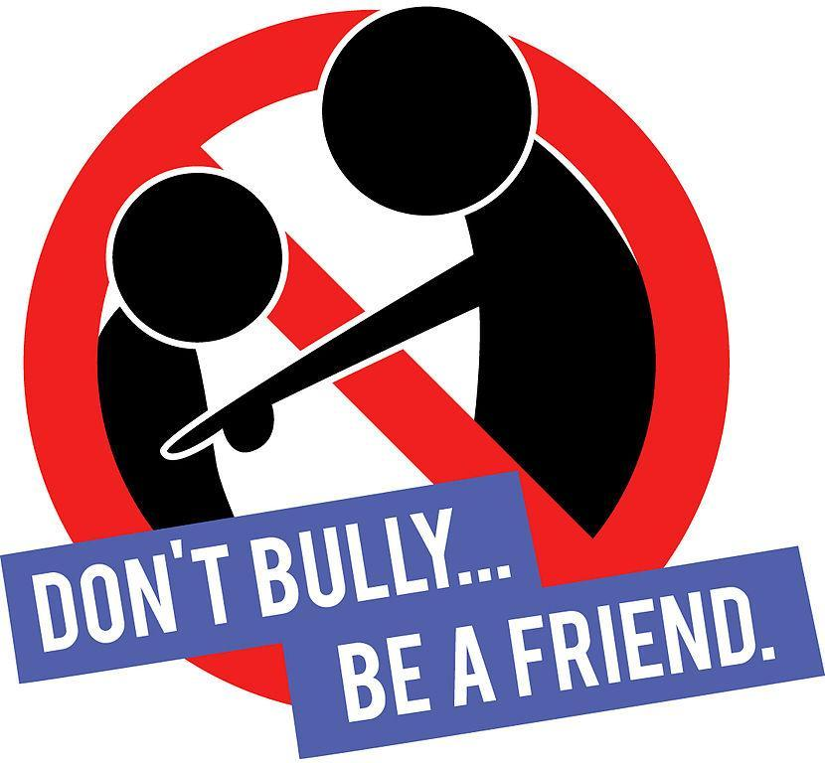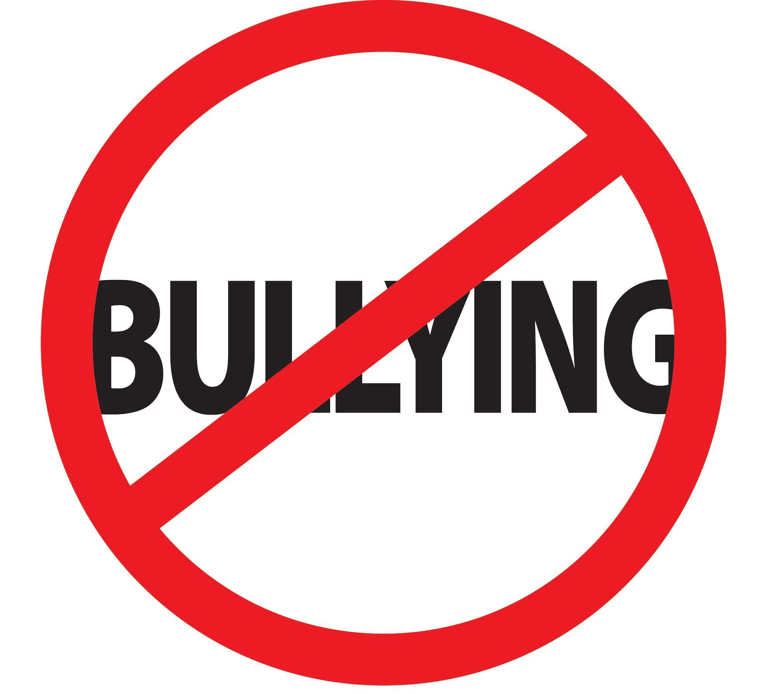

What to do if you get bullied

If you think you are being bullied then you should:
- Ask them to STOP
- Ignore them
- Find a member of staff or Mission leader
- Walk away
- Talk to a friend

What is Bullying?
Bullying is when somebody continuously decides to hurt you. This could be physically, such as punching, kicking, slapping etc; Or it could be mentally which could be, mean words, name calling, talking about them behind their back etc;
S everal
T imes
O n
P urpose

What do I do if I see someone else being bullied?
- Don’t try and get involved- you might end up getting hurt.
- Don’t stay silent- tell someone or the bullying will keep happening.
Who can you go to in school?
- Mental Health Champions
- Staff in school
- Your class teacher
- Mrs Webb and Mrs Pound

What not to do

- Get angry
- Hit them
- Think it’s your fault
- Do what they say

